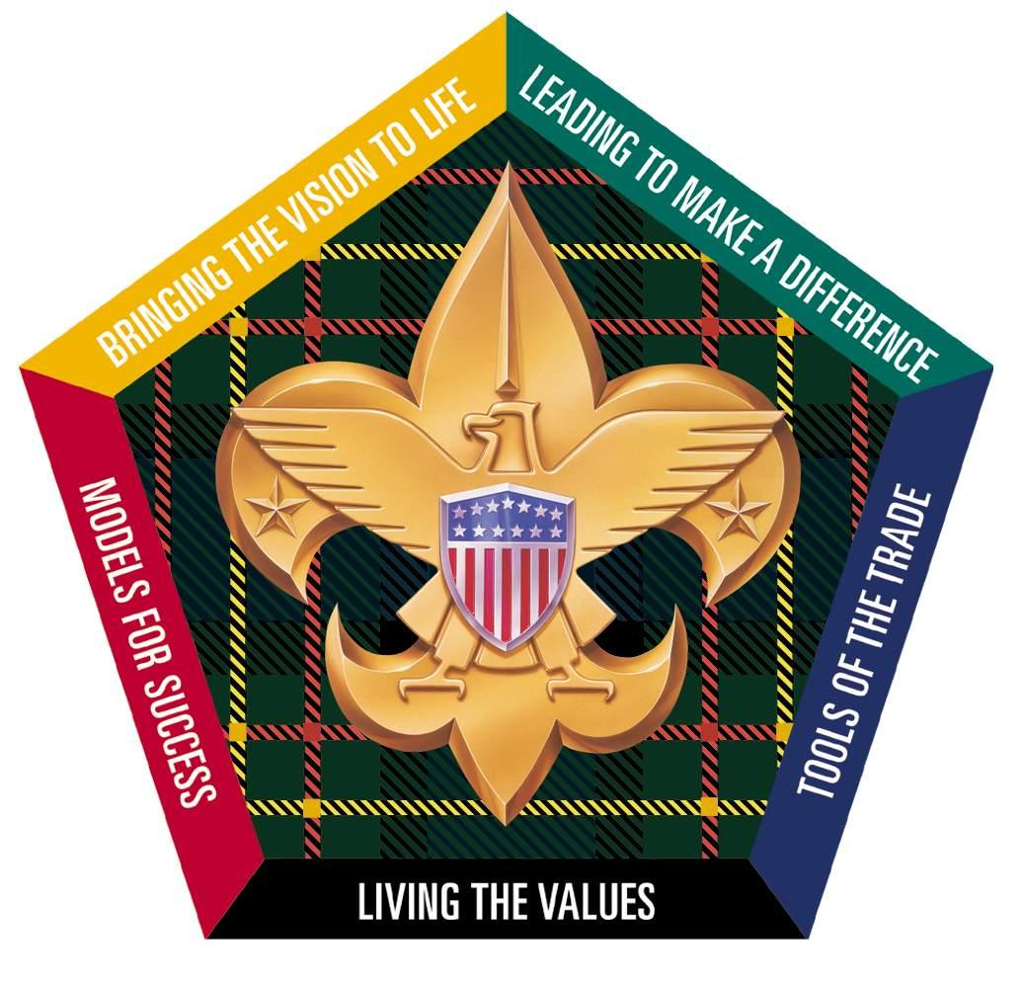

S7-427-17

Wood Badge

Ticket Workbook

**Participant Name: Matthew Ballance**  **Course Number: S7-427-17**

Wood Badge

Ticket Workbook

**Purpose:**

The purpose of a Wood Badge Ticket is to help you realize your personal vision of your role in Scouting. Ideally, you will write your ticket around your primary job in Scouting.

**Four parts of a ticket:**

* A ticket consists of four parts:
* A list of your personal values
* A description of your Scouting role
* A statement of your vision of success
* A mission composed of five significant goals that can be attained within 18 months.

**Realization of your vision:**

You should not expect that you will realize your vision immediately upon completion of the five goals; reaching your goals is an initial part of a long-term work in progress.

**Use of Skills:**

It is assumed that you will use most or all of the skills you learned during the Wood Badge course. In writing your ticket it will help if you list the skills you can use to accomplish your goals. It is not required that you incorporate all of the skills presented during the course into your goals.

**Diversity:**

At least one goal must address increasing diversity within the Boy Scouts of America.

**Wood Badge Ticket Vision and Values**

**Personal Values:**

Values are our core beliefs or desires that guide or motivate our attitudes and actions. List your values and the forms that they take; principles, standards, personal qualities, character traits, or codes of ethics. Keep in mind the values of Scouting.

* Honesty
* Consistency
* Helpfulness
* Loyalty
* Creativity
* Curiosity
* Eagerness
* Happiness

**Job Description:**

Describe your job in Scouting; the role that you fulfill. It may be helpful to confer with your group leader to review your role so that you understand what responsibilities you have.

* Be the link between the unit and the district and council
* Give advice when needed to help the unit grow and deliver the program
* Provide information to the unit leadership from events around the council and neighboring councils related to training
* Help ensure that the unit is healthy and able to deliver the program in accordance with the charter
* Provide a resource to help the unit with the “paperwork” of scouting

**Vision Statement:**

Scouting is a safe means for young men and women to learn how to be effective leaders and develop a lifelong love of learning and growing, expanding on the skills and morals taught from family, church, the scouting program, and the community at-large.

**Goals:**

The remainder of the Wood Badge ticket focuses on your goals. There should be a minimum of 5 goals that can be attained in less than 18 months. One of the goals must address increasing diversity in the Boy Scouts of America. Use one page for each goal.

**Additional Notes for My Ticket Vision and Values:**

**~~Name:~~** ~~Matthew Ballance~~ **~~Wood Badge Ticket Goal:~~**  ~~1 of 5~~

**~~MY Scouting Position:~~** ~~Unit Commissioner~~

**~~Team That Will Benefit From My Leadership:~~** ~~District Scouters and roundtable staff~~

**~~SMART Goal~~** *~~(Specific, Measurable, Attainable, Relevant and Timely):~~*

* ~~Specific~~
* ~~Measurable~~
* ~~Attainable~~
* ~~Relevant~~
* ~~Timely~~

**~~WHO~~** ~~(~~*~~Person/s or group/s who will be affected by this goal)~~***~~:~~**

* ~~Roundtable Staff~~

**~~WHAT~~** ~~(~~*~~A brief description of the action you plan to take to help make your vision a reality)~~***~~:~~**

~~Provide a webpage to record attendance, provide notification by various means to unit leaders with agendas before the roundtable, and provide a follow up with the items discussed for leaders that were unable to attend.~~

**~~WHERE~~** ~~(~~*~~Setting or locations for the action item work)~~***~~:~~**

* ~~Online~~

**~~WHEN~~** ~~(~~*~~Time-frame for the action item work)~~***~~:~~**

~~All work to be completed no later than 8 months after initial sprint begins. Initial demo to be ready after 3~~~~rd~~ ~~sprint, with final deliverable provided after 5~~~~th~~ ~~sprint.~~

**~~HOW~~** ~~(~~*~~Describe the steps you will take to complete this action item. Details and descriptions should reflect the SMART guideline)~~*~~:~~

* ~~Using agile methodology, design, develop, and deliver an on-line system (possibly web based) to provide support for scheduling and notification of roundtable programs to the scouters in the district.~~

**~~WHY (~~***~~Tell why this action item is important to you and how it relates to your vision for your group)~~***~~:~~**

~~This helps create program excellence by ensuring that unit leaders have adequate notification of upcoming roundtables, upcoming important dates, and any district, council, or national program news that affects their areas. It will also provide a means to get information to scouters that are unable to attend the roundtable in person in a timely manner. It also allows for potential future growth and expansion to meet district needs once this goal is accomplished. This application can also help to further the goals of inclusion and diversity by providing information to scouters that are traditionally unable to attend the roundtables due to previous obligations (such as work and family) and ensuring that they are able to have a similar experience to those that are able to attend in-person.~~

**~~HOW VERIFIED~~** ~~(~~*~~Describe how you and your troop guide will know when this action item is completed)~~***~~:~~**

~~Review and inspection of the following items by my ticket counselor:~~

* ~~The program will be available in a demo format to user for evaluation.~~
* ~~Sprint records will be kept showing progress toward the eventual deliverable product.~~
* ~~Source code will be held in a GitHub repository and made available on request~~
* ~~Documentation will be provided to end users on how to use the system~~

**~~Ticket Counselor Approval:~~**~~_________________________________________________~~ **~~Date:~~**~~_______________~~

**Name: Matthew Ballance Wood Badge Ticket Goal:**  1R of 5

**MY Scouting Position: Unit Commissioner**

**Team That Will Benefit From My Leadership: Wachovia District Scouts and Scouters**

**SMART Goal** *(Specific, Measurable, Attainable, Relevant and Timely):*

* Specific
* Measurable
* Attainable
* Relevant
* Timely

**WHO** (*Person/s or group/s who will be affected by this goal)***:**

* Scout leaders, Scouts and their families

**WHAT** (*A brief description of the action you plan to take to help make your vision a reality)***:**

* Offer to develop and restart the distribution of a district online newsletter to keep district scouts and scouters informed and up to date on events from Wachovia district, Old Hickory Council, and other events of interest to the scouting family.

**WHERE** (*Setting or locations for the action item work)***:**

* The newsletter will initially be crafted online and submitted to the District Key3 for approval before being sent to the membership.

**WHEN** (*Time-frame for the action item work)***:**

First edition to be sent following the District Roundtable for November, 2017

**HOW** (*Describe the steps you will take to complete this action item. Details and descriptions should reflect the SMART guideline)*: Topics discussed at the Commissioner’s Staff meeting, district committee meeting, and District roundtable will be edited into short discussion-style stories and included in the “above the fold” section of the newsletter. The running district/council calendar will be update to remove past events and add newer events as they come up.

**WHY (***Tell why this action item is important to you and how it relates to your vision for your group)***:**

Many scouters in the district, due to previous work and family obligations are not able to attend the roundtables or committee meetings. As a result, the quality of the information they have for use in planning and that they can then distribute to the members of their respective units can suffer. By providing the summaries of news that affects our district and council to the members, in a format that they can read and process on their schedule, as well as keep as a reference, will help to make sure that our district stays informed on upcoming events that affect them, as well as program changes (requirements for advancement, policy changes, etc..) that they may or may not be able to receive. Also, by using email to push the information to the end-user vs using social media and requiring the end-user to pull the information, we have a better chance of actually getting their attention and converting them from a passive “I think I remember someone mentioning that” consumer to an active “I’ve got the email right here” user of the programming information.

The newsletter is not intended to be a full-on replacement for attendance at these meetings, but more as a bridge to cross the gaps that can occur as we lead ever busier lives with more and more demands on our time.

**HOW VERIFIED** (*Describe how you and your troop guide will know when this action item is completed)***:**

Review and inspection of the following items by my ticket counselor:

* The troop guide/ticket councilor will be added (with permission) to the distribution list and sent each copy of the newsletter that is produced.

**Ticket Counselor Approval:**_________________________________________________ **Date:**_______________

**Name:** Matthew Ballance **Wood Badge Ticket Goal:**  2 of 5

**MY Scouting Position:** Unit Commissioner

**Team That Will Benefit From My Leadership: District Scouters**

**SMART Goal** *(Specific, Measurable, Attainable, Relevant and Timely):*

* **Specific**
* **Measurable**
* **Attainable**
* **Relevant**
* **Timely**

**WHO** (*Person/s or group/s who will be affected by this goal)***:**

* Unit committee members, unit committee chairpersons, unit leadership

**WHAT** (*A brief description of the action you plan to take to help make your vision a reality)***:**

* Develop a roundtable presentation on the “paperwork side of scouting”

**WHERE** (*Setting or locations for the action item work)***:**

* District roundtable meeting

**WHEN** (*Time-frame for the action item work)***:**

All work to be completed no later than 12 months from the start of the ticket

**HOW** (*Describe the steps you will take to complete this action item. Details and descriptions should reflect the SMART guideline)*:

* A lesson plan will be developed to explain the administration side of scouting.
* Copies of required forms will be provided with sample data entered
* Help sheets for online forms will be developed to give examples of where data is entered
* Visual Aids for use in the presentation (displaying screenshots, paperwork examples, and/or reference cards) will be developed

**WHY (***Tell why this action item is important to you and how it relates to your vision for your group)***:**

This helps create program excellence by ensuring that units are accurately filing required documentation for their units on schedule. This will help to lead to consistency in how units provide their information to the council.

**HOW VERIFIED** (*Describe how you and your troop guide will know when this action item is completed)***:**

Review and inspection of the following items by my ticket counselor:

* Obtain course approval from District Training Chair
* Content review by District Training Chair
* Training will be delivered to the unit positions responsible

**Ticket Counselor Approval:**__________________________________________________ **Date:**_______________

**Name:** Matthew Ballance **Wood Badge Ticket Goal:**  3 of 5

**MY Scouting Position:** Unit Commissioner

**Team That Will Benefit From My Leadership:** Unit Commissioner Staff

**SMART Goal** *(Specific, Measurable, Attainable, Relevant and Timely):*

* Specific
* Measurable
* Attainable
* Relevant
* Timely

**WHO** (*Person/s or group/s who will be affected by this goal)***:**

* Unit Key three

**WHAT** (*A brief description of the action you plan to take to help make your vision a reality)***:**

* Develop a guideline to assist with the development and implementation of Unit Service Plans that allows for specific tailoring to the unit and tracking throughout the year during unit visits and tracking back to the unit’s specific Service Plan.
* Specific rubric will allow for tracking progress against the Unit Service Plan,
* Provide a uniform way to quantify the unit’s development against the strengths and weaknesses as identified in the Unit Service Plan

**WHERE** (*Setting or locations for the action item work)***:**

* Delivered during Commissioner’s Staff Meeting, used by commissioners during unit visits

**WHEN** (*Time-frame for the action item work)***:**

All work to be completed no later than 10 months from project initiation

**HOW** (*Describe the steps you will take to complete this action item. Details and descriptions should reflect the SMART guideline)*:

* Develop the rubric used to score progress against the unit service plan, over several iterations
* Develop the format to display the scoring
* Deploy the tool in a format that is accessible to commissioners in the field.

**WHY (***Tell why this action item is important to you and how it relates to your vision for your group)***:**

This helps create program excellence by ensuring that we are delivering a consistent measurement on progress of the units we serve with respect to the unit service plan that is developed during the detailed assessment that leads to the unit service plan.

**HOW VERIFIED** (*Describe how you and your troop guide will know when this action item is completed)***:**

Review and inspection of the following items by my ticket counselor:

* The district commissioner will approve the final product as meeting the standards of the district and the commissioner program.
* Copies of the worksheet will be made available to the ticket councilor for review

**Ticket Counselor Approval:**__________________________________________________ **Date:**_______________

**Name:** Matthew Ballance **Wood Badge Ticket Goal:**  4 of 5

**MY Scouting Position:** Unit Commissioner

**Team That Will Benefit From My Leadership:** Unit and Chartered Organizations

**SMART Goal** *(Specific, Measurable, Attainable, Relevant and Timely):*

* Specific
* Measurable
* Attainable
* Relevant
* Timely

**WHO** (*Person/s or group/s who will be affected by this goal)***:**

* Unit Commissioners

**WHAT** (*A brief description of the action you plan to take to help make your vision a reality)***:**

* Develop a Charter Presentation Ceremony to use for units when re-chartering

**WHERE** (*Setting or locations for the action item work)***:**

* Chartering Organization’s meeting

**WHEN** (*Time-frame for the action item work)***:**

All work to be completed no later than 3 months from project initiation

**HOW** (*Describe the steps you will take to complete this action item. Details and descriptions should reflect the SMART guideline)*:

* Collect list of all units in the district and the type of organization that is sponsoring the unit (church, civic group, etc..)
* Develop a specific ceremony that incorporates the Charter Organization’s community goals into the presentation
* Print/publish the resulting ceremony to a forum (commissioner staff meeting, for example) to allow every commissioner an opportunity to utilize the ceremony at the next charter presentation.

**WHY (***Tell why this action item is important to you and how it relates to your vision for your group)***:**

This helps create program excellence by recognizing the organizations that give their resources to provide the scouting program. By showing our gratitude to the CO, we can help strengthen ties between the BSA, Council, and District and the organization that will help us when we need more from them (membership assistance, financial assistance, volunteers, eagle project opportunities, etc…) Also, giving this recognition to the chartering organization rather than mailing the certificate is part of our oath to be courteous, cheerful, and in the case of a religious organization, reverent.

**HOW VERIFIED** (*Describe how you and your troop guide will know when this action item is completed)***:**

Review and inspection of the following items by my ticket counselor:

* Copies of the various ceremonies will be published and available to the ticket councilor at the conclusion of the project, and after the District Commissioner’s approval.
* Drafts will be periodically submitted to the ticket councilor for advice and input.

**Ticket Counselor Approval:**_________________________________________________ **Date:**_______________

**Name:** Matthew Ballance **Wood Badge Ticket Goal:**  5 of 5

**MY Scouting Position:** Unit Commissioner

**Team That Will Benefit From My Leadership:** Scouts and Scouting families

**SMART Goal** *(Specific, Measurable, Attainable, Relevant and Timely):*

* Specific
* Measurable
* Attainable
* Relevant
* Timely

**WHO** (*Person/s or group/s who will be affected by this goal)***:**

* Scouts and their families

**WHAT** (*A brief description of the action you plan to take to help make your vision a reality)***:**

* Develop a program to bring awareness to the religious emblems program and assist in delivering that program and in recruitment of adult mentors for youth that pursue the awards.

**WHERE** (*Setting or locations for the action item work)***:**

* Developed offline
* Presented to Units during unit visits
* Executed by scouts and their families in conjunction with their religious leaders

**WHEN** (*Time-frame for the action item work)***:**

All work to be completed no later than 1 year from project initiation

**HOW** (*Describe the steps you will take to complete this action item. Details and descriptions should reflect the SMART guideline)*:

* Begin identifying people in the district that would make good District and Unit Religious Emblems Coordinators
* Develop a tool-kit of information and promotional literature to support the work of the District and Unit RECs
* Develop a program to encourage scouts at summer camp to pursue the Duty to God at Summer Camp program and earn the Summer Camp award

**WHY (***Tell why this action item is important to you and how it relates to your vision for your group)***:**

This helps create program excellence by encouraging all members of the BSA to show the last point of the scout law, being reverent, and exemplifying the point of the scout oath to do our duty to God. While we don’t teach any specific religious creed, furthering our beliefs helps to create a more well-rounded scout, and by extension, a more well-rounded citizen.

**HOW VERIFIED** (*Describe how you and your troop guide will know when this action item is completed)***:**

Review and inspection of the following items by my ticket counselor:

* A quick presentation will be given at a roundtable meeting to introduce the REC position to the units, and from this, a list of potential candidates for the REC role will be developed.
* A promotional display will be developed and displayed (with permission) at district events, and information provided to scouts and scouters regarding the religious emblems program in the BSA
* Will work with the District Commissioner and District Executive to identify and support the district REC and if not currently filled, officially fill the role of District Religious Emblems Coordinator.

**Ticket Counselor Approval:**_________________________________________________ **Date:**_______________

**Name: Matthew Ballance Wood Badge Ticket Goal:**  1R of 5

**MY Scouting Position: Unit Commissioner**

**Team That Will Benefit From My Leadership: Wachovia District Scouts and Scouters**

**SMART Goal** *(Specific, Measureable, Attainable, Relevant and Timely):*

* **Specific**
* **Measurable**
* **Attainable**
* **Relevant**
* **Timely**

**WHO** (*Person/s or group/s who will be affected by this goal)***:**

* Scout leaders, Scouts and their families

**WHAT** (*A brief description of the action you plan to take to help make your vision a reality)***:**

* Begin distribution of a district newsletter/email blast to keep district scouts and scouters informed and up to date on events from Wachovia district, Old Hickory Council, and

**WHERE** (*Setting or locations for the action item work)***:**

* The newsletter will initially be crafted online and submitted to the District Key3 for approval before being sent to the membership.

**WHEN** (*Time-frame for the action item work)***:**

First edition to be sent following the District Roundtable for November, 2017

**HOW** (*Describe the steps you will take to complete this action item. Details and descriptions should reflect the SMART guideline)*: Topics discussed at the Commissioner’s Staff meeting, district committee meeting, and District roundtable will be edited into short discussion-style stories and included in the “above the fold” section of the newsletter. The running district/council calendar will be update to remove past events and add newer events as they come up.

**WHY (***Tell why this action item is important to you and how it relates to your vision for your group)***:**

Many scouters in the district, due to previous work and family obligations are not able to attend the roundtables or committee meetings. As a result, the quality of the information they have to use to plan and distribute to their units can suffer. By providing the summaries of news that affects our district and council to the members, in a format that they can read and process on their schedule, as well as keep as a reference, will help to make sure that our district stays informed on upcoming events that affect them, as well as program changes (requirements for advancement, policy changes, etc..) that they may or may not be able to receive. Also, by using email to push the information to the end-user vs using social media and requiring the end-user to pull the information, we have a better chance of actually getting their attention and converting them from a passive “I think I remember someone mentioning that” consumer to an active “I’ve got the email right here” user of the programming information.

**HOW VERIFIED** (*Describe how you and your troop guide will know when this action item is completed)***:**

Review and inspection of the following items by my ticket counselor:

* The troop guide/ticket councilor will be added (with permission) to the distribution list and sent each copy of the newsletter that is produced.

**Ticket Counselor Approval:**_________________________________________________ **Date:**_______________